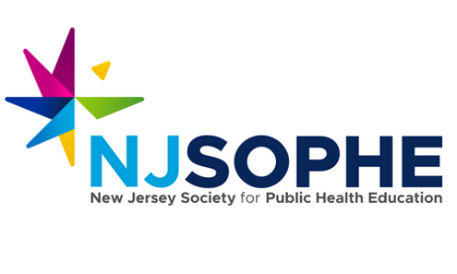

The Public Heath Career Club – Scholarship Application
Please submit application to sonikashankargarcia@gmail.com
Deadline: August 31, 2022
Winner Announcement: We can provide this scholarship to 10 NJ SOPHE members. Winners will be announced by September 9, 2022.

- Please provide your name, title, and organization you are a part of. Please include a short summary of the work you do.
- How long have you been working within the public health field?
- What excites you most about the opportunity to be a part of the Public Health Career Club?
- Please list 3 things that you are hoping to get out of this club/program?

Thank you so much for your interest!

